**Multisite creation in magento2**

**Step1:** Login to Magento admin section

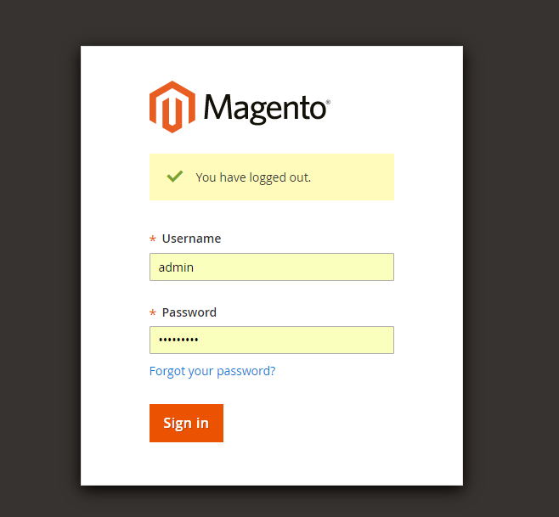

**Step2:** In the left navigation manu

**Click on Stores🡪 All Stores**

Click on Create Website button on the right, It will navigate to a web form, Fill details as shown below. Then click on Save Web Site button at the top right corner. Make Sure code column has the unique code with other websites

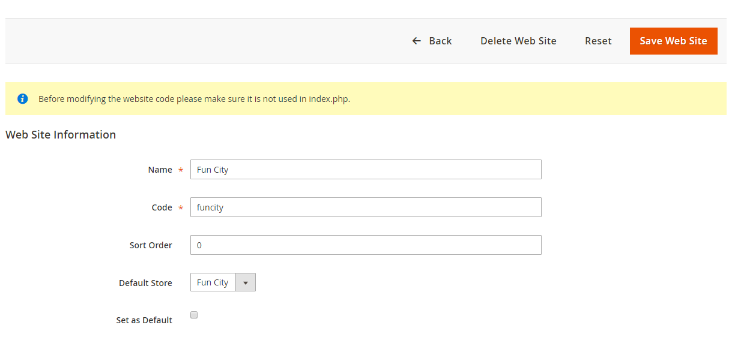

**Step3:** Click on **Create Store** at the top right

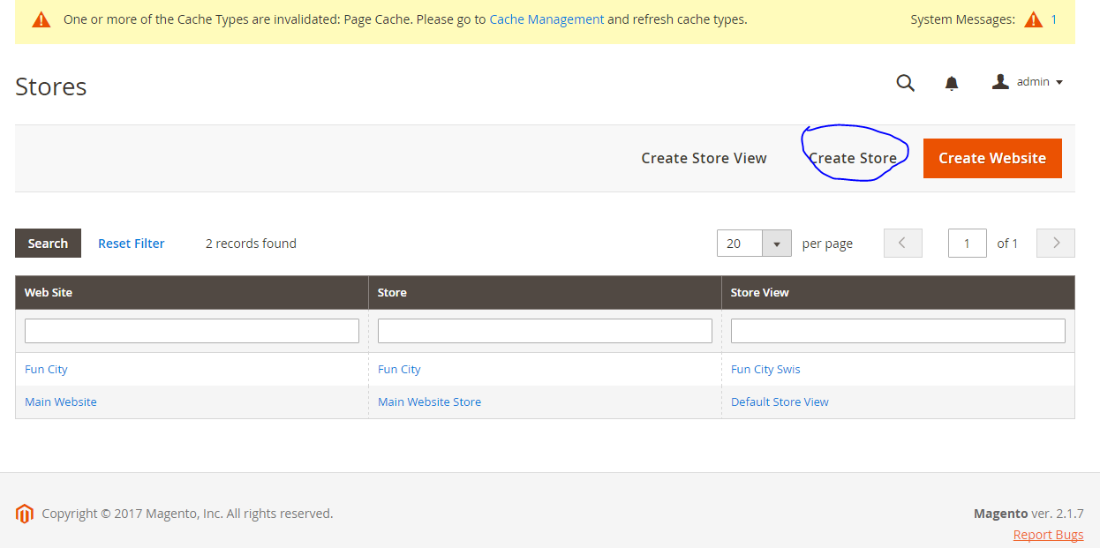

Fill the details as shown below and Click on **Save Store** button.

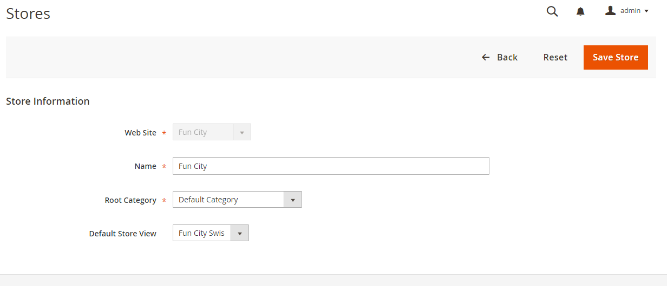

Step4: Click on **Create Store View** link

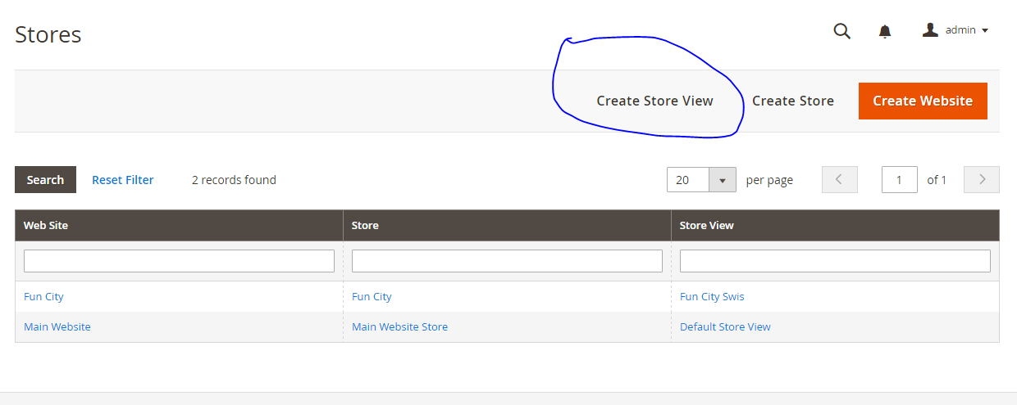

Fill the details as shown below, Click on Save Store View. Make Sure code column has the unique code with other store views. This can be same with the website code, But If there are multiple store views in a website we have to use unique for each store view.

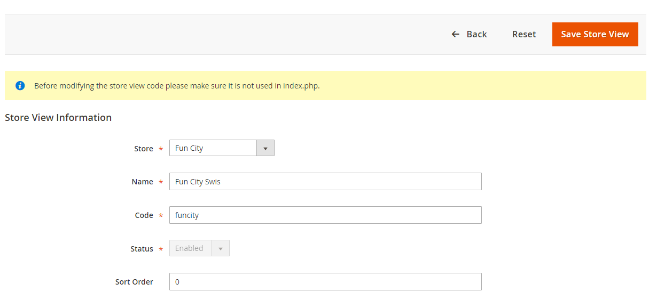

**Step5: Click on Stores 🡪 Configurations**

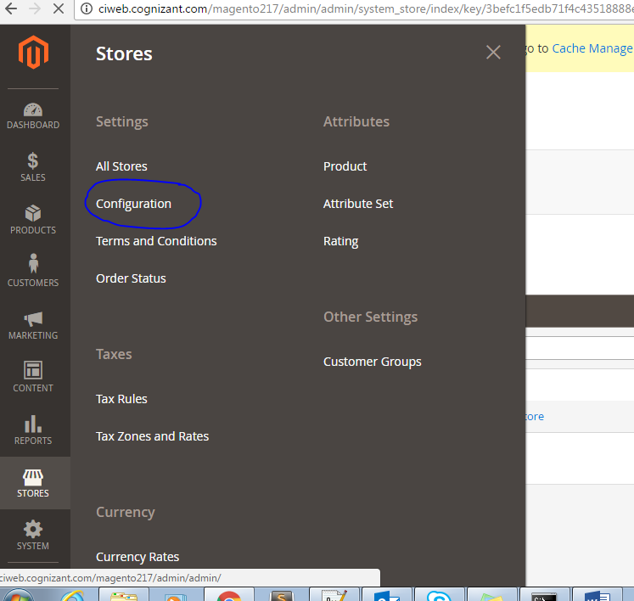

Select Recently created website in Store View dropdown. Click on Web menu in the left navigation

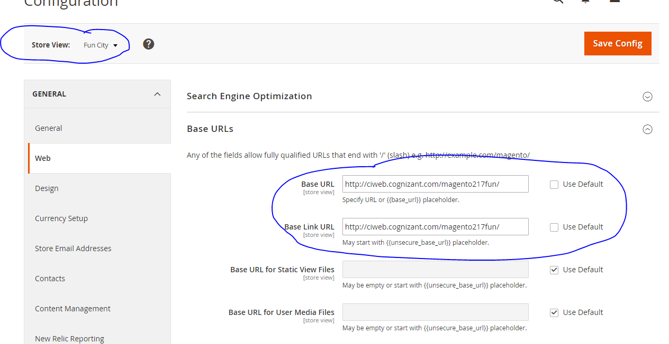

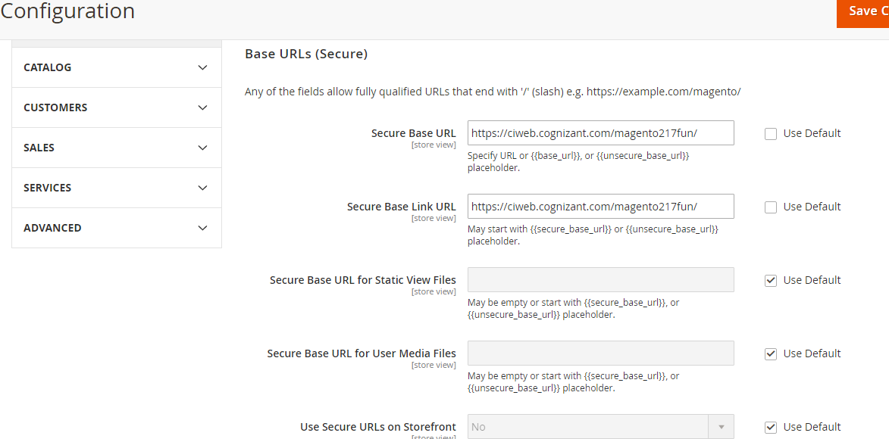

Change the Base URL and Base Link Url values with the virtual host created for this website

Virtual host Creation

Edit httpd-vhosts.conf file (will be fount in apache installation folder) and give the entries like below screenshot. Give the Server alias and MAGE_RUN_CODE, MAGE_RUN_TYPE. Please go through the google if you need further clarifications on Virtualhost and MAGE_RUN_CODE, MAGE_RUN_TYPE.

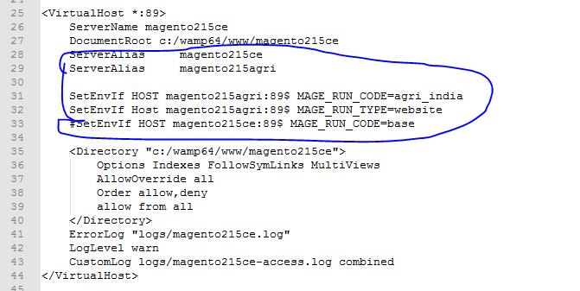

Edit Windows host file like below screenshot and give an entry for virtualhost

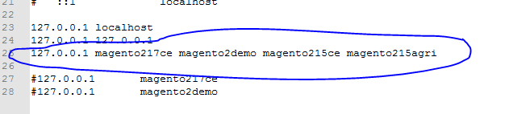

That’s all. You Are done with multistore setup.

Flush the cache and reindex all

Open the browser and hit url.